Course: CS420 - Artificial Intelligence

06 – ID3 Decision trees and MLP

Question 1. Roger Federer is one of the greatest tennis players since tennis have been invented. We want to learn a little about what makes Federer win or lose a match. To do so, we gathered data from games played by R. Federer, shown in the below table.
ID | Time | Match Type | Court Surface | Best Effort | Outcome
1 | Morning | Master | Grass | True | Win
2 | Afternoon | Grand slam | Clay | True | Win
3 | Night | Friendly | Hard | False | Win
4 | Afternoon | Friendly | Mixed | False | Lose
5 | Afternoon | Master | Clay | True | Lose
6 | Afternoon | Grand slam | Grass | True | Win
7 | Afternoon | Grand slam | Hard | True | Win
8 | Afternoon | Grand slam | Hard | True | Win
9 | Morning | Master | Grass | True | Win
10 | Afternoon | Grand slam | Clay | True | Lose
11 | Night | Friendly | Hard | False | Win
12 | Night | Master | Mixed | True | Lose
13 | Afternoon | Master | Clay | True | Lose
14 | Afternoon | Master | Grass | True | Win
15 | Afternoon | Grand slam | Hard | True | Win
16 | Afternoon | Grand slam | Clay | True | Win
- Build a classification model using ID3 decision tree from the gathered data.
The entropy of the whole dataset
- H(Dataset) =
The information gain of the attribute Time
- H(Time = Morning) =
- H(Time = Afternoon) =
- H(Time = Night) =
- AE(Time) =
- IG(Time) =
The information gain of the attribute Match Type
- H(Match Type = Master) =
- H(Match Type = Grand slam) =
- H(Match Type = Friendly) =
- AE(Match Type) =
- IG(Match Type) =
The information gain of the attribute Court Surface
- H(Court Surface = Grass) =
- H(Court Surface = Hard) =
- H(Court Surface = Clay) =
- H(Court Surface = Mixed) =
- AE(Court Surface) =
- IG(Court Surface) =
The information gain of the attribute Best Effort
- H(Best Effort = True) =
- H(Best Effort = False) =
- AE(Best Effort) =
- IG(Best Effort) =
The root attribute will be
Repeat for every branch of the root attribute that has examples not fully classified into a single class
- Knowing the conditions in which a tennis match takes place, we would like to predict whether R. Federer will win or lose the match, using ID3 decision tree in a.
Time | Match type | Court Surface | Best Effort | Outcome
Morning | Grand Slam | Grass | True | ?
Afternoon | Friendly | Clay | False | ?

Question 2. A perceptron has two input units, a unipolar step function, weights $w_{1}=0.2$ and $w_{2}=-0.5$, and a threshold $θ=0.2$ (note that, θ can be considered as a weight for an extra input which is always set to $-1$).
- The actual output for the input pattern $x={[1, 1]}^{T}$ is
- The perceptron is now trained using the learning rule $w = (d – y)x$, where $x$ is the input vector, is the learning rate, $w$ is the weight vector, $d$ is the desired output, and $y$ is the actual output. What are the new values of the weights and threshold after one step of training with the input vector $x={[0, 1]}^{T}$ and desired output 1, with $= 0.2$?
$$y$$ | $$w_{1}$$ | $$w_{2}$$ | $$θ$$
- Show the equation of the decision line for the perceptron before training

- Show the equation of the decision line for the perceptron after training with the input vector in b.

Question 3. In the network shown aside, all the units have binary inputs (0 or 1), unipolar step functions and binary outputs (0 or 1). The weights for this network are $w_{31}=1, w_{32}=1, w_{41}=1, w_{42}=1$ and $w_{43}=-2$. The threshold of the hidden unit (3) is 1.5 and the threshold of the output unit (4) is 0.5. The threshold of both input units (1 and 2) is 0.5, so the output of these units is the same as the input.  Compute the output at every neuron for all pairs of input values.  $$x_{1}$$ $$x_{2}$$ Neurons  1 2 3 4  0 0  0 1  1 0  1 1 | 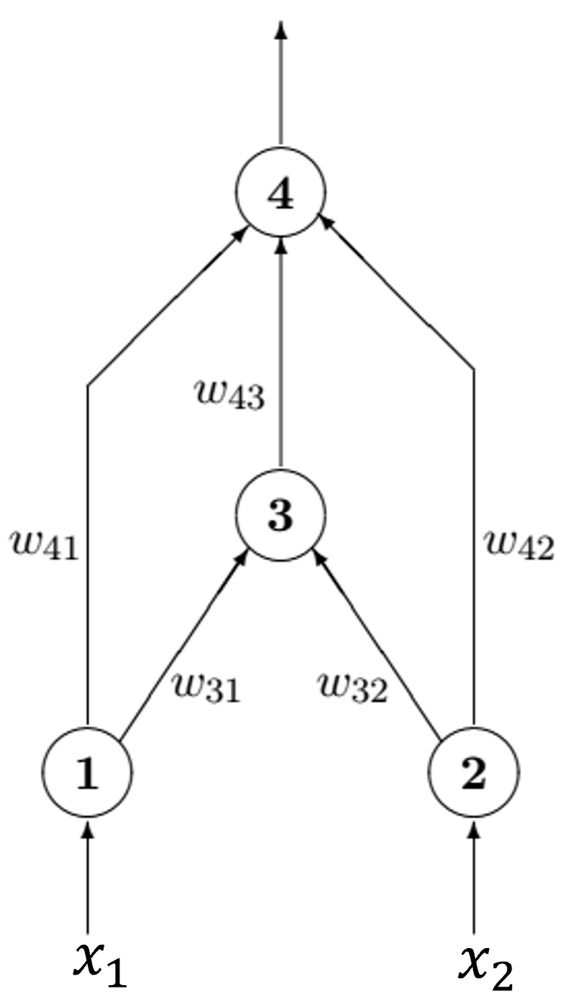
Which Boolean functions can be computed by this network?

Question 4. A single-layer network of perceptrons has 3 input units and 3 output units. No threshold or bias is considered.
The network has weights.

Question 5. A multi-layer feedforward network has 5 input units, a first hidden layer with 4 units, a second hidden layer with 3 units, and 2 output units. No threshold or bias is considered.
If no threshold (or bias) is used the network has weights.
If threshold (bias) is used, the network has weights.

Question 6. Suppose you have the following three-layered multi-layer neural networks. No threshold is considered. The pattern to be learned is $x={[0, 1]}^{T}$ with desired output $y_{d}=0$. The learning rate is 0.25.  The weight vectors are  $w_{1}=\left[\begin{matrix}0.62 \\ 0.55\end{matrix}\right] w_{2}=\left[\begin{matrix}0.42 \\ -0.17\end{matrix}\right]$ $w_{3}=\left[\begin{matrix}0.35 \\ 0.81\end{matrix}\right]$ | 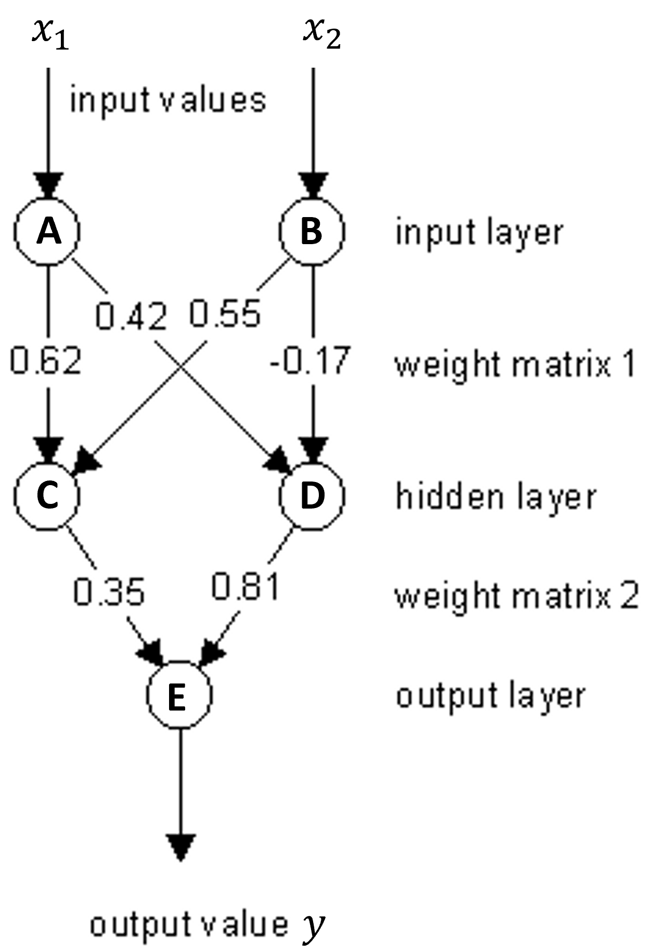
- Compute the output at every neuron when the pattern is propagated through the net.
A | B | C | D | E

- Adjust the weights when the backpropagation takes place.
$$w_{11}$$ | $$w_{12}$$ | $$w_{21}$$ | $$w_{22}$$ | $$w_{31}$$ | $$w_{32}$$

